Power BI Gateway Resilience for Azure VM SQL Server
Oct 26, 2026

Purpose and scope
The Power BI standard gateway is a single point of failure today; adding a second gateway to form a cluster removes it. This document explains why a gateway is needed, what breaks when the office workstation fails, and how to make the setup highly available.
In scope: Power BI Service datasets and dashboards that refresh from, or query, a SQL Server instance running on an Azure VM in an Azure VNet, through the standard (on-premises) data gateway.
Out of scope: Power BI Report Server, Azure SQL Database or Managed Instance, and personal-mode gateways.

Why is a gateway needed
A gateway is required because the Power BI Service runs in Microsoft's cloud and cannot reach a SQL Server that is not publicly exposed. SQL Server on an Azure VM is a customer-managed server on a private IP inside your VNet, so Power BI treats it like any other private data source, even though it sits in Azure. A Microsoft partner's gateway guide lists SQL Server on Azure VMs among the typical gateway use cases.
- Import / scheduled refresh: the gateway runs the query on the SQL Server and returns the rows to the service.
- DirectQuery / live connection: every slicer click, filter or visual load becomes a live query through the gateway, so an outage breaks the dashboard immediately, not only at the next refresh.
- No inbound ports: the gateway only makes outbound connections (TCP 443, 5671, 5672 and 9350–9354), so SQL Server need not be exposed to the internet.
The alternative, giving SQL Server a public endpoint and connecting directly, is not recommended: it widens the attack surface and is outside normal security practice for a production database.

Current setup and the single point of failure
One standard gateway on one office workstation carries all Power BI traffic to SQL Server, so losing that machine stops every refresh and Direct Query report.

current setup · 1 gateway, 1 point of failure
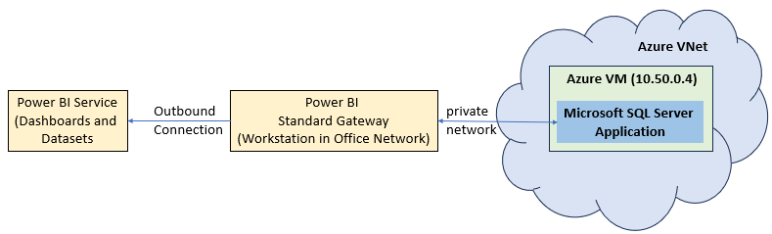

Any of the following incident will take the gateway offline:
- Hardware failure of the workstation
- Office power or internet outage
- Loss of the office-to-Azure network link
- A restart, sleep or Windows update on a desktop-class machine

Failover options compared
A gateway cluster with at least one member inside Azure is the best fit: it keeps your existing gateway, data sources and licensing, and fails over without manual steps. A cluster is a group of two or more gateway installations that Power BI treats as one gateway; if the primary is unavailable, requests go to another member.
Option | What it fixes | Main drawback | Fit
Cluster with a second office workstation | Hardware failure of one machine | Both members still depend on the office power, internet and the office-to-Azure link | Partial
Cluster of 2+ gateway VMs in Azure, same VNet as SQL Server | Machine, zone and office-network failures | Two small VMs to run and patch | Recommended
Hybrid cluster: office workstation + Azure VM | Machine failure; office members can be retired later | Mixed network paths, so refresh speed differs by member | Good transition step
Virtual network (VNet) data gateway | Microsoft manages the gateway, so no gateway servers to fail | Requires Premium or Fabric capacity (A4 or higher, or any F or P SKU); confirm SQL Server on a VM is supported for your scenario | Evaluate if you already have capacity
Cold standby: rebuild the gateway from the recovery key | Recovery after a failure | Manual, hours of downtime, not high availability | Backup only

A cluster is the standard Microsoft-supported answer for this exact problem: Microsoft documents high-availability clusters as the way to avoid a single point of failure when accessing on-premises data from Power BI and other cloud services.

Recommendation: a cluster with Azure-hosted members
Add two gateway VMs in Azure to the existing gateway as cluster members, then keep the office workstation as an optional extra or retire it. Power BI sees one gateway, so datasets and reports need no changes.

SQL Server stays reachable with this approach
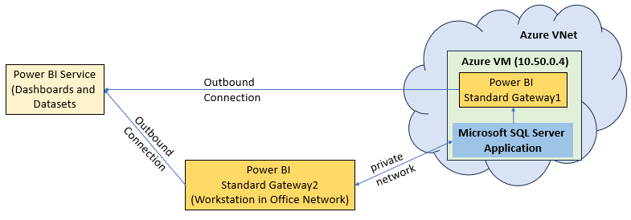
recommended setup · one cluster, 1 Azure member + 1 workstation
- Removes the office from the path: office power, internet and the office-to-Azure link no longer matter to refreshes.
- Sits next to the data: Microsoft guidance says that for best performance the gateway and its sources should be in the same datacenter.
- Survives a zone or host failure: the two VMs sit in different availability zones.
- Fails over without manual steps: the service uses the primary gateway unless it is unavailable, then moves to another member.

Implementation steps
The change takes about a day and needs no changes to datasets or reports, because the cluster keeps the existing gateway name and data sources.
- Get the recovery key. Locate the key set when the office gateway was installed; it is required to add a member to the cluster. If it is lost, plan for a new gateway and re-pointing the data sources instead.
- Open the network paths. Allow the gateway VMs outbound on TCP 443, 5671, 5672 and 9350–9354. Allow the gateway subnet to reach SQL Server on TCP 1433 in the NSG and in the Windows firewall on the SQL VM.
- Install the latest gateway on VM, choose Add to an existing gateway cluster, select the current gateway and enter the recovery key.
- Confirm the members. In Power BI Manage connections and gateways, the cluster should list the office workstation and Azure VM as online.
- Check name resolution. Data source definitions are shared across the cluster, so the SQL Server name in each data source must resolve and connect from every member.
- Choose the routing mode in the cluster settings: failover only (requests go to the primary and move on if it is unavailable), or distribute requests across all members for load balancing.
- Test the failover. Stop the gateway service on the office workstation, run a scheduled refresh and open a DirectQuery report, and confirm both succeed through an Azure member. Repeat by stopping each member in turn.

Operations and monitoring
A cluster only protects you while every member stays healthy, so the members need the same care as the primary.
- Patching: gateway updates are not installed automatically, and Microsoft supports only the last six monthly releases. Update members one at a time so the cluster stays available, and keep all members on the same version.
- Recovery key: store it in Azure Key Vault or another approved vault, with access for at least two administrators.
- Gateway admins: assign several admins in Power BI so one person leaving does not block changes; Microsoft recommends multiple administrators.
- Alerting: set refresh-failure notifications on critical semantic models, and add Azure Monitor alerts for VM heartbeat and for the gateway service stopping, so a lost member is noticed before the last one fails.
- Network check: run the gateway app's Diagnostics network ports test after any firewall or NSG change.
- Backups: back up the gateway VMs with Azure Backup so a failed member can be restored quickly, then rejoined using the recovery key.
- Expected behaviour: failover is automatic for new requests, but a refresh or query running at the moment a member dies may fail and need a retry.

Risks and open questions
Item | Risk or question | Action
Recovery key | If lost, new members cannot join the existing cluster | Confirm it exists before starting
Personal-mode gateway | Personal mode cannot be clustered | Confirm the current gateway is standard mode (stated in the request)
Credentials and SSO | Gateway data sources using Windows or Kerberos delegation need the new VMs set up to match | Check each data source's authentication
Region | Cluster members and the Power BI tenant region should align to avoid added latency | Deploy the VMs in the Azure region closest to the SQL VM
Single SQL Server VM | The gateway is only one failure point; the SQL VM itself is another | Consider SQL Always On or an Azure VM availability design
Cost | Two always-on VMs add a monthly compute cost | Size small and review after a month of metrics

List of Power BI Dashboards and Reports impacted with this Gateway Configuration:

BI Dashboard List.xlsx

